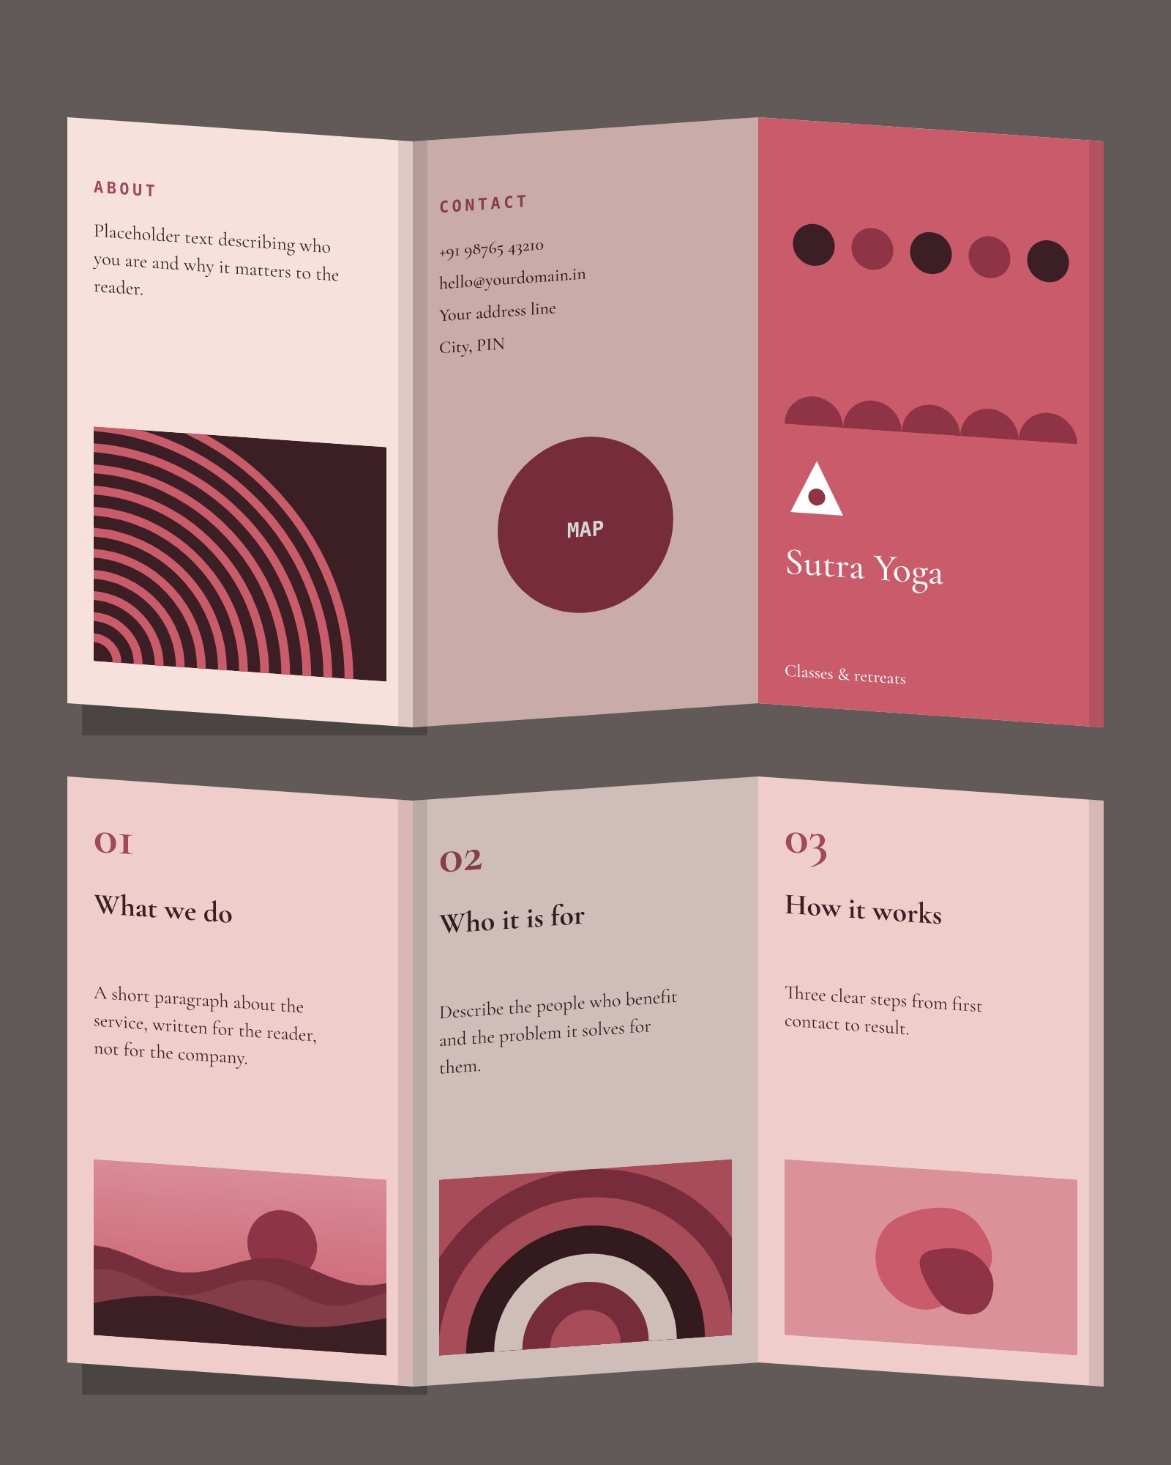
OUTSIDE
INSIDE
Sutra Yoga — tri-fold brochure, A4 landscape, outside & inside · Z-fold view

