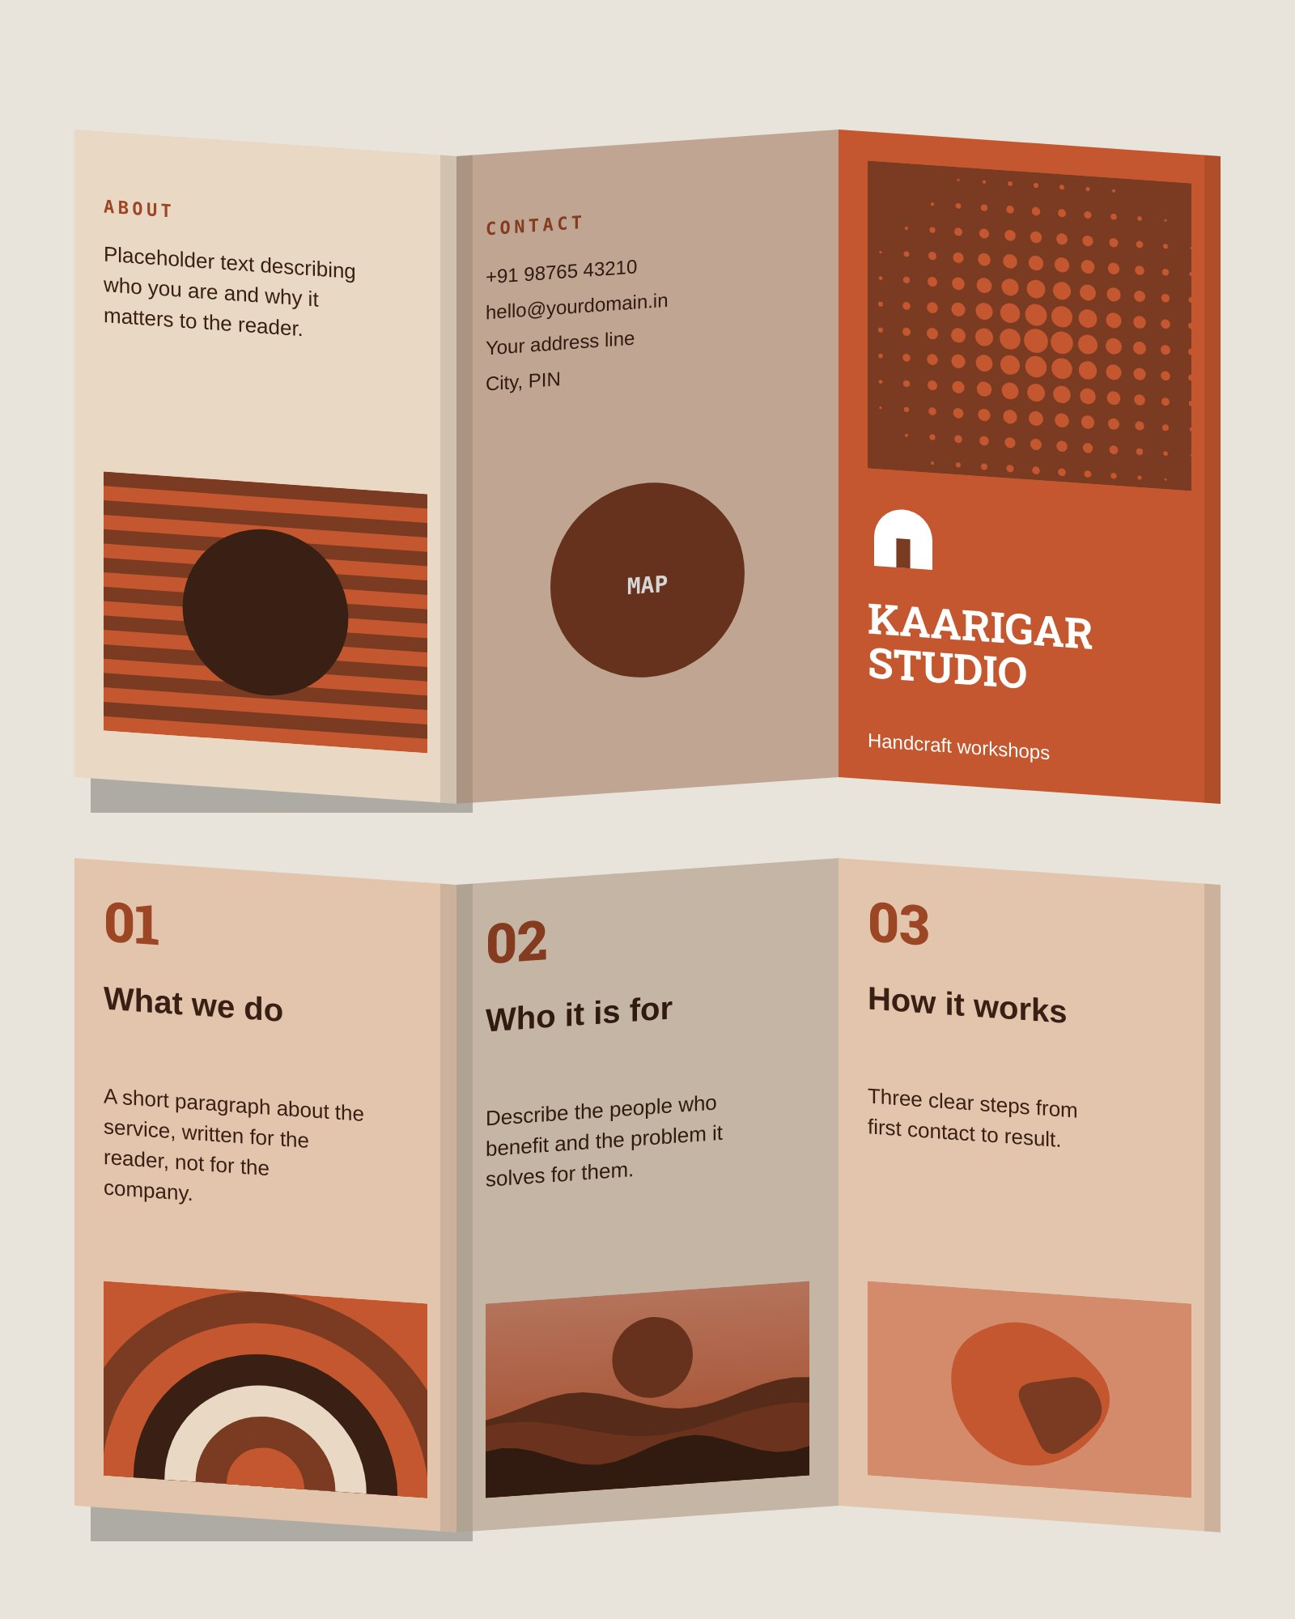
OUTSIDE
INSIDE
Kaarigar Studio — tri-fold brochure, A4 landscape, outside & inside · Z-fold view

