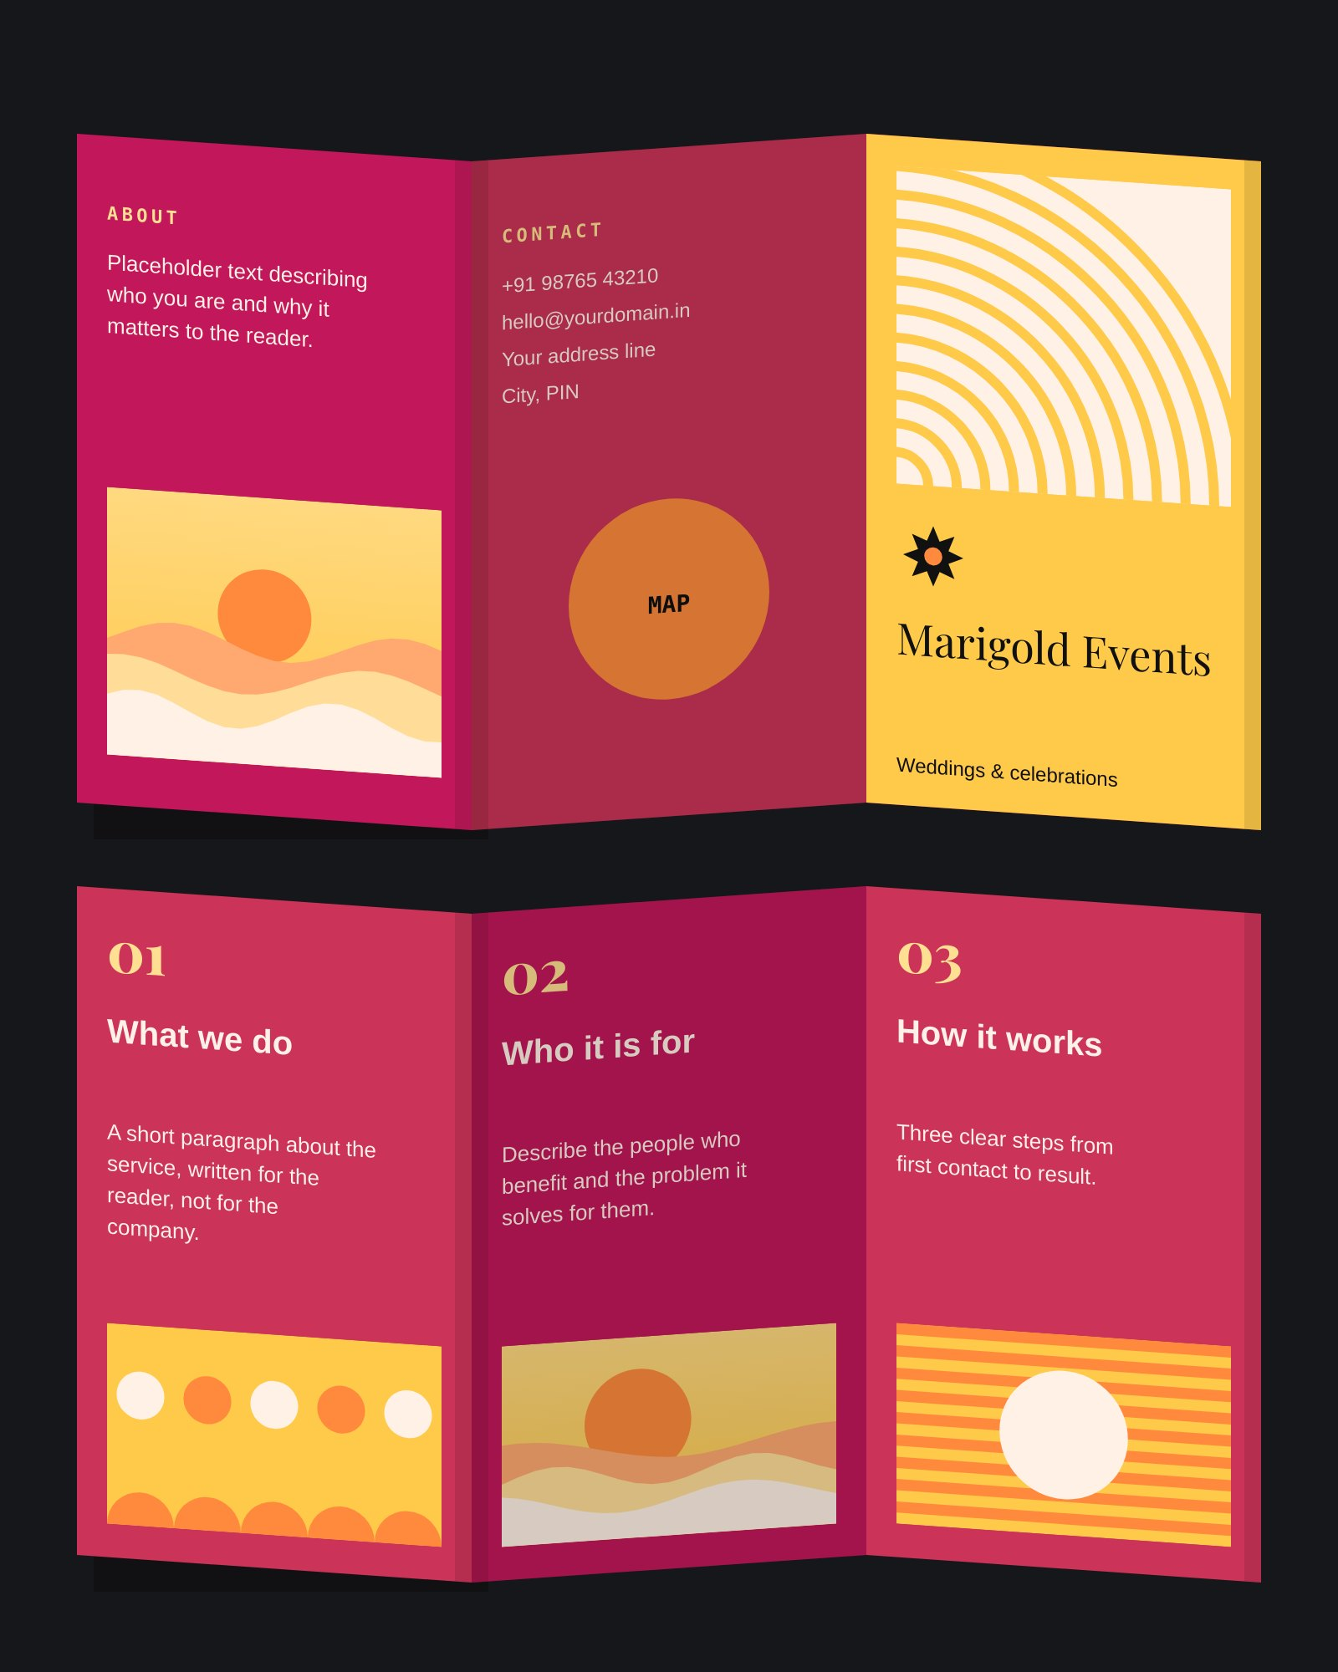
OUTSIDE
INSIDE
Marigold Events — tri-fold brochure, A4 landscape, outside & inside · Z-fold view

