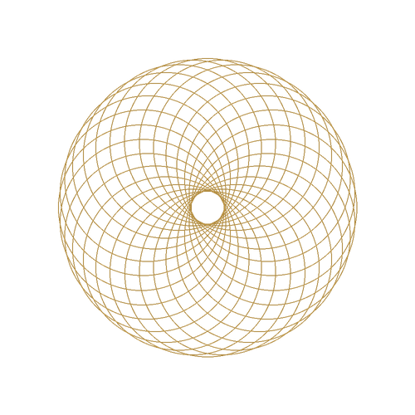
Certificate of Completion

UI Design Bootcamp
This certificate is proudly presented to
Aarav Mehta
for successfully completing the 12-week programme in interface design, including research, wireframing, visual design and a final portfolio project.

Ritika Sharma  Programme Director |  | 14 October 2026  Date of issue

Northlight Labs · Certificate No. NL-UID-2026-0142

