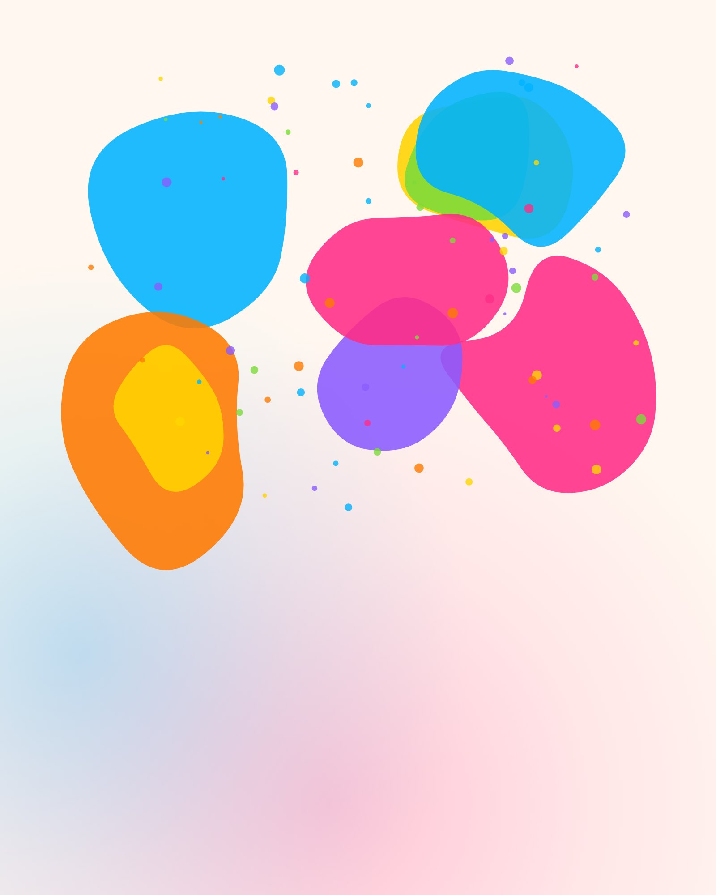
होली मुबारक
Happy
Holi
Let the colours be loud and the grudges be gone.
BURA NA MANO, HOLI HAI!

