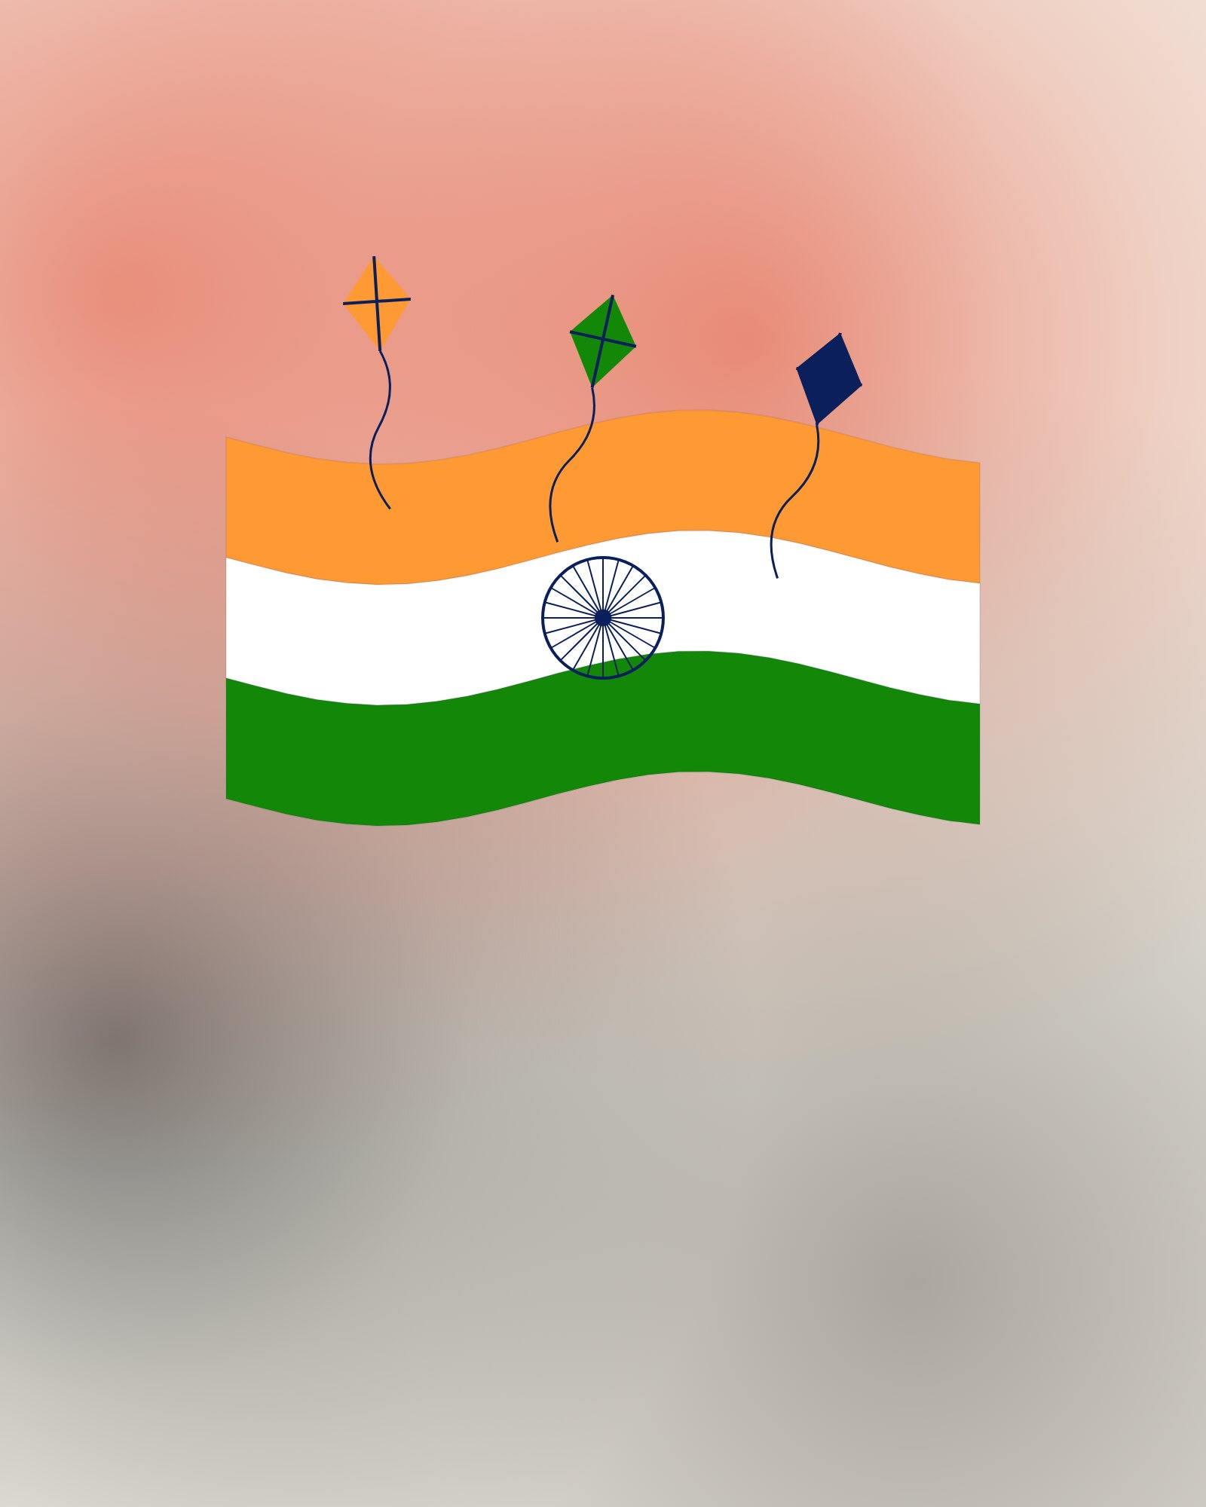
WE THE
PEOPLE
Three words that began everything. Happy
Republic Day.
26 JANUARY
REPUBLIC DAY
JAI HIND

