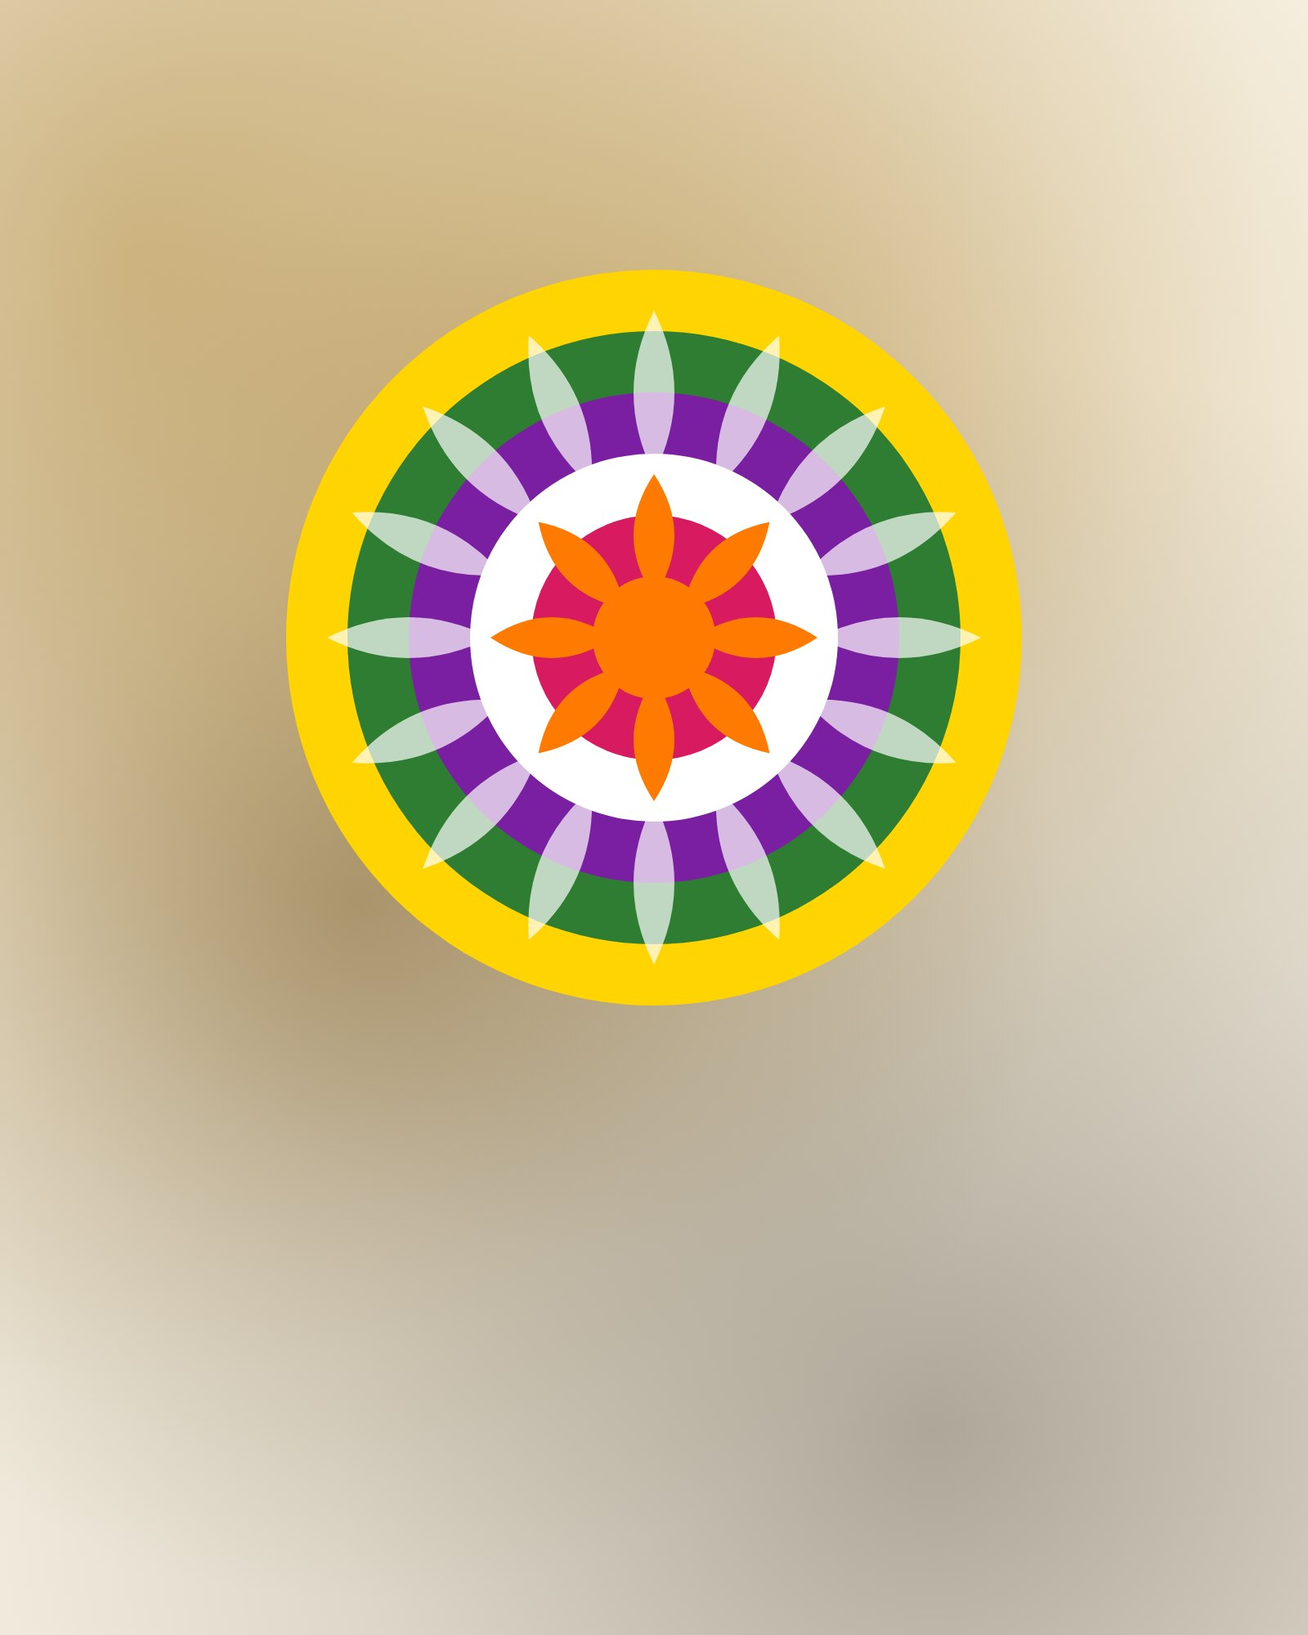
Happy
Onam
Pookalam at the door, sadya on the leaf and the whole
family home.
HARVEST FESTIVAL
SEP
ONASHAMSAKAL

