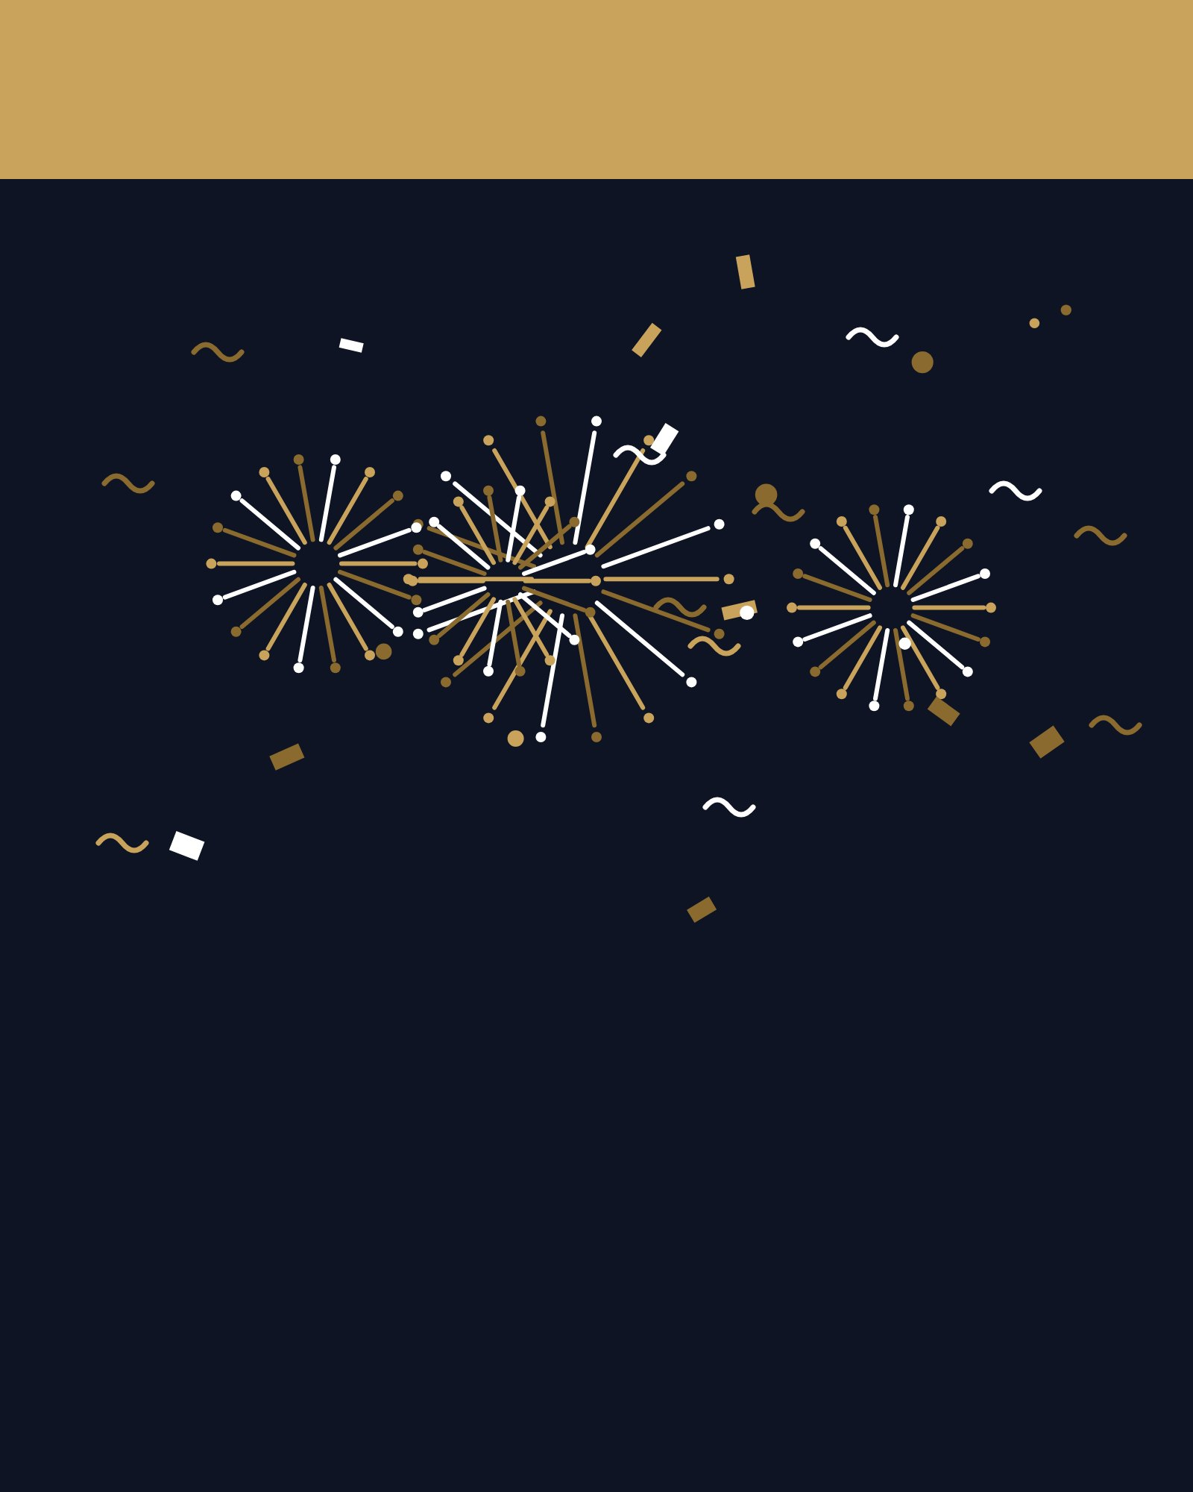
COUNTDOWN
Ten, Nine,
Eight…
Thank you for an amazing year. See you on the
other side.
SAMPLE NYE PARTY

