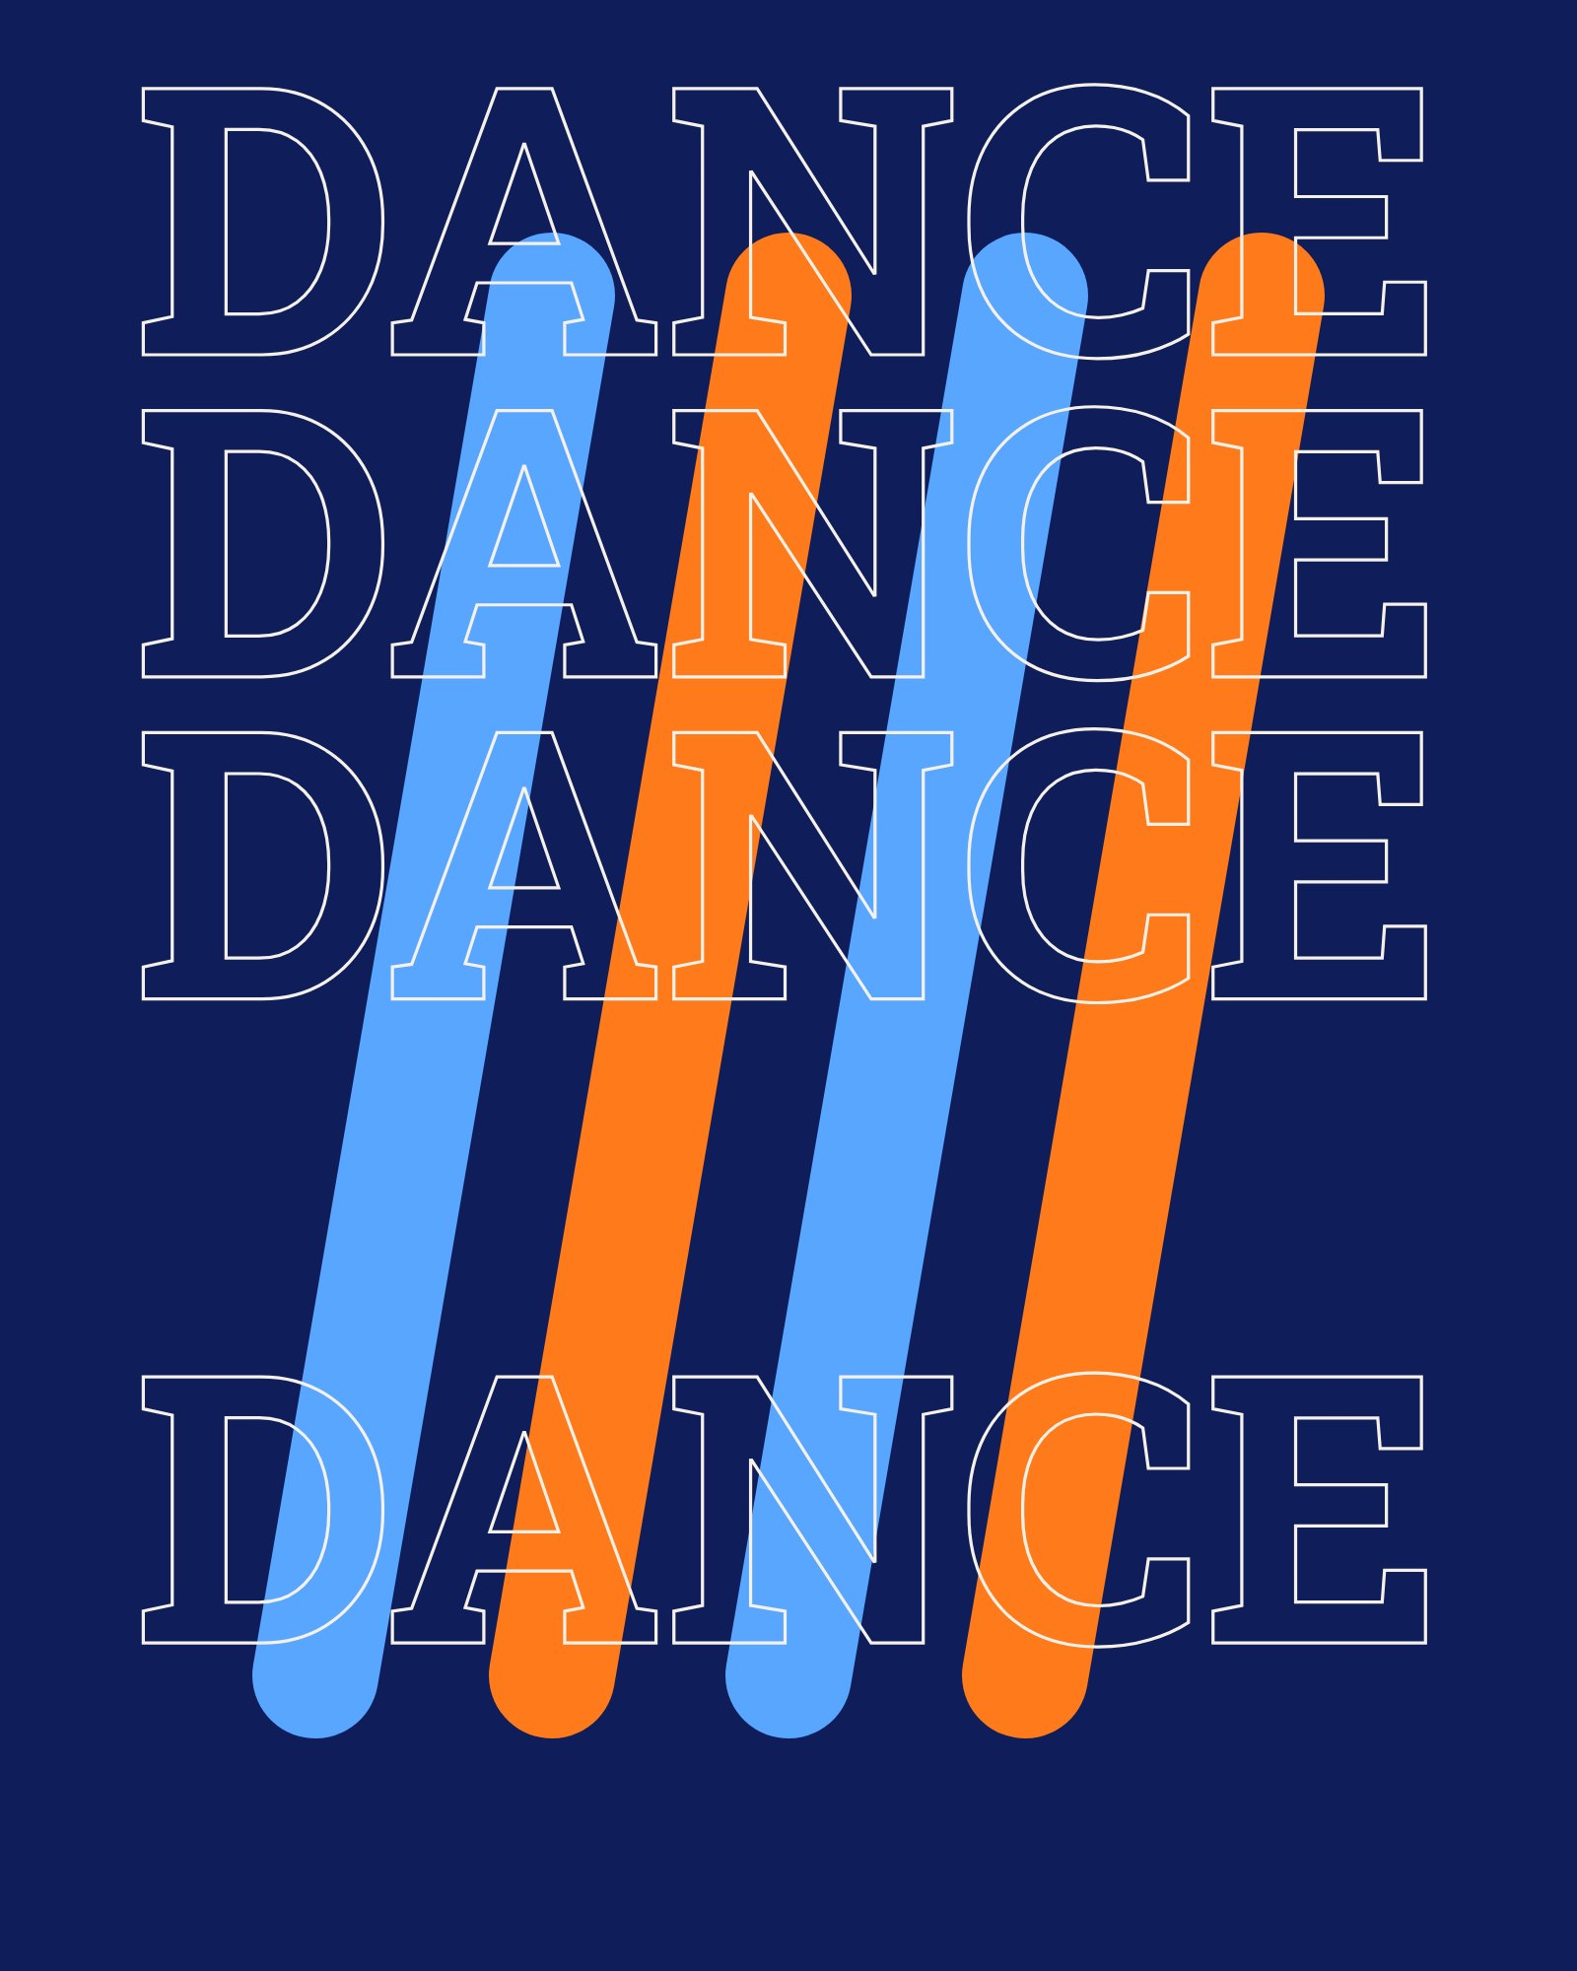
DANCE
ZUMBA
Cardio
MON/THU
6 PM
DURATION
50 min

