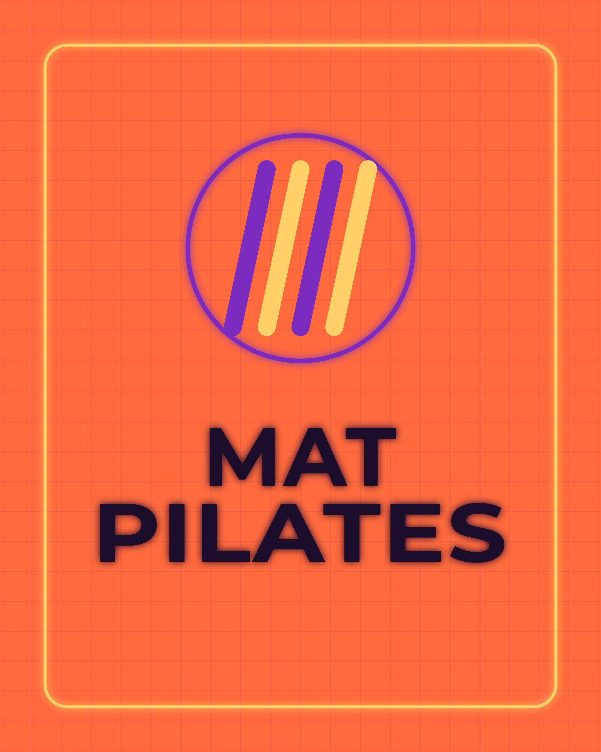
Core, mobility and balance — low impact, high
focus.
8 AM / PROVIDED / 10

