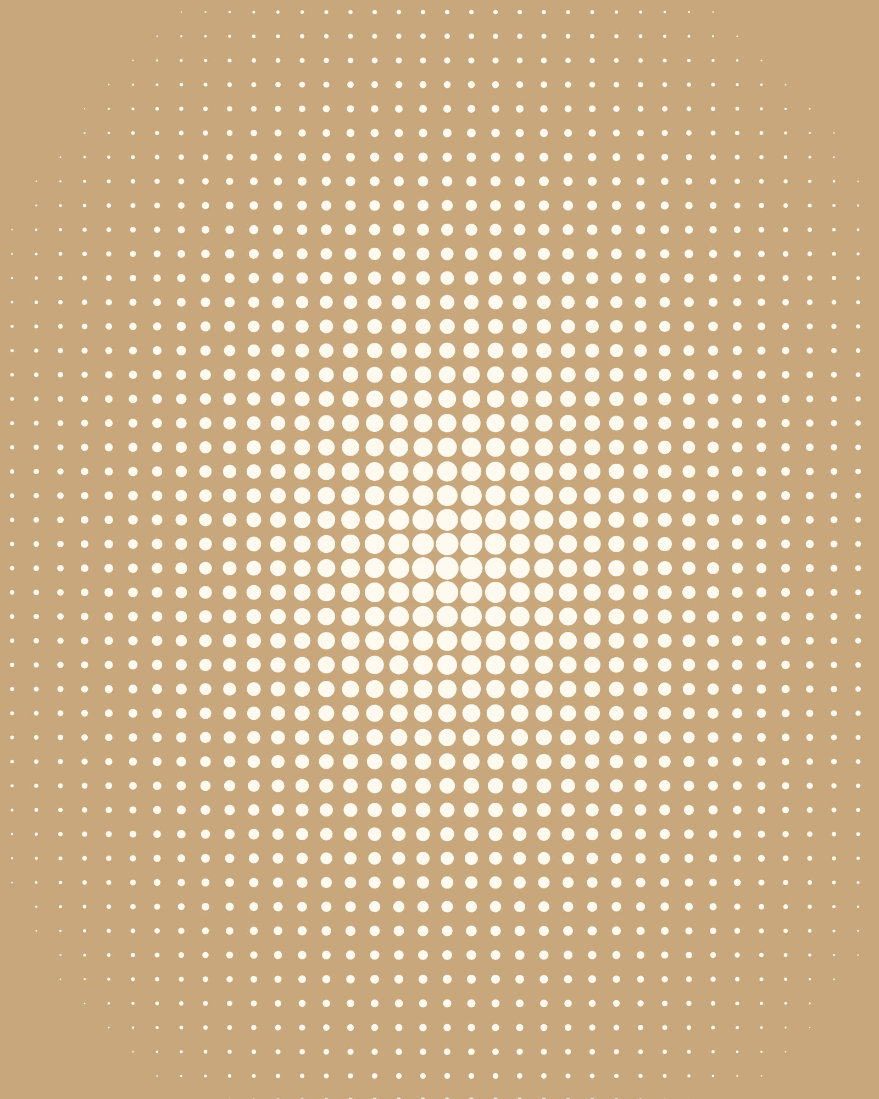
CONCRETE
POETRY
ARCHITECTURE WEEK
Walks, drawings and conversations about the
buildings we live in.
12–18 JAN

