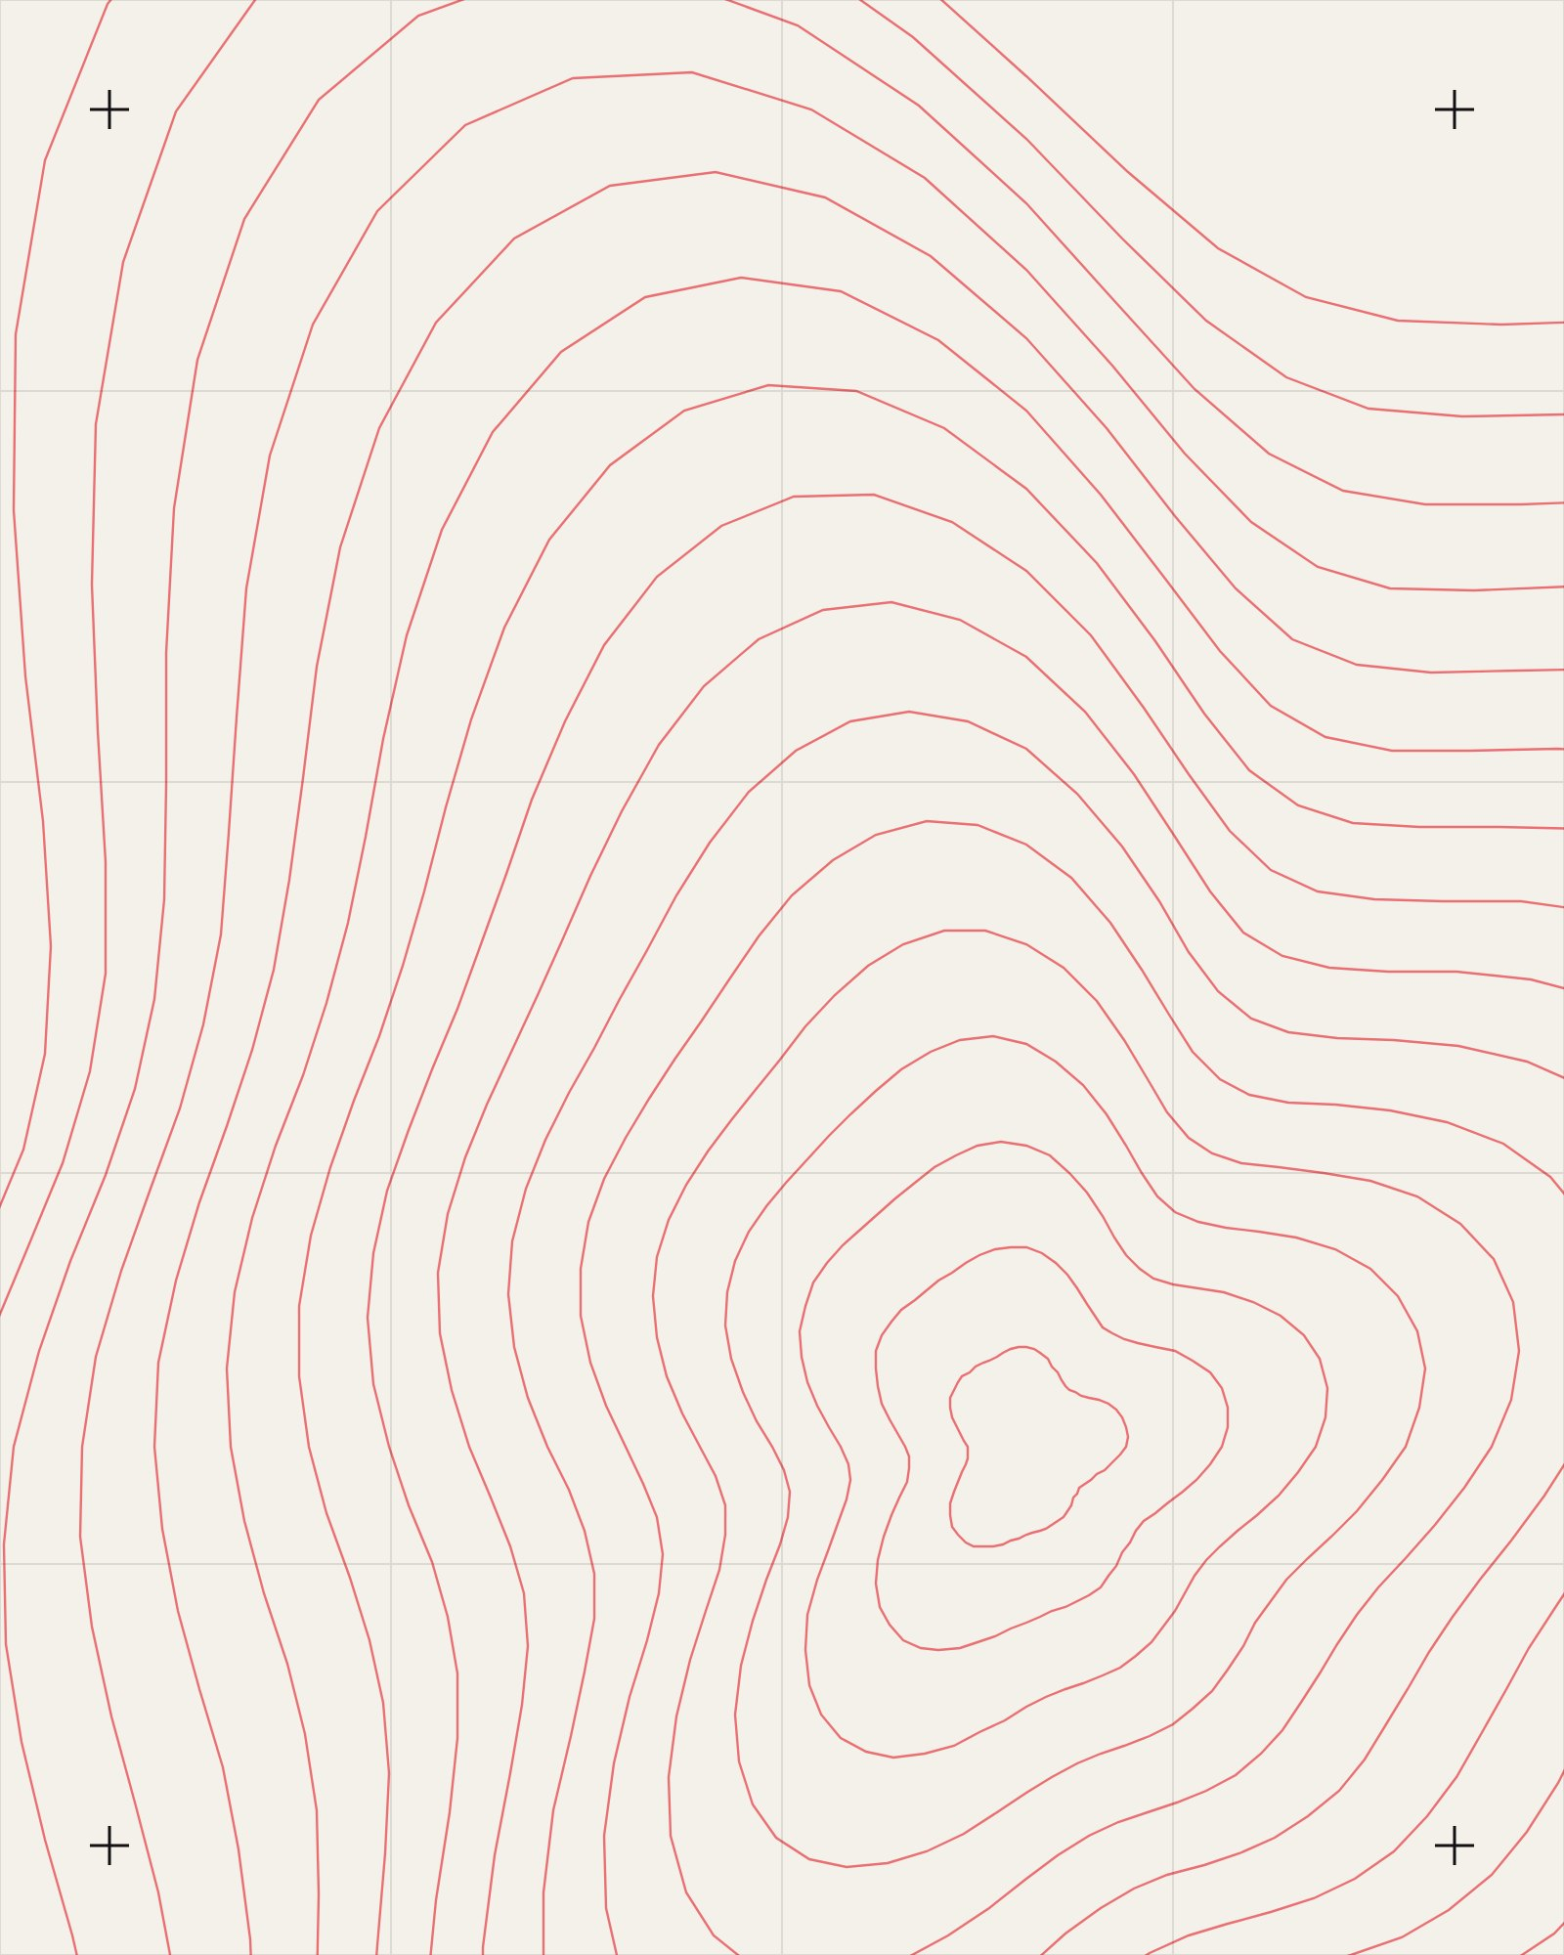
SPACE WEEK
N 28.61° / E 77.20°
Look
Up
Telescopes on the lawn, talks on moons and a
DATES
4–10 Oct
SHOWS
12
AGES
All

