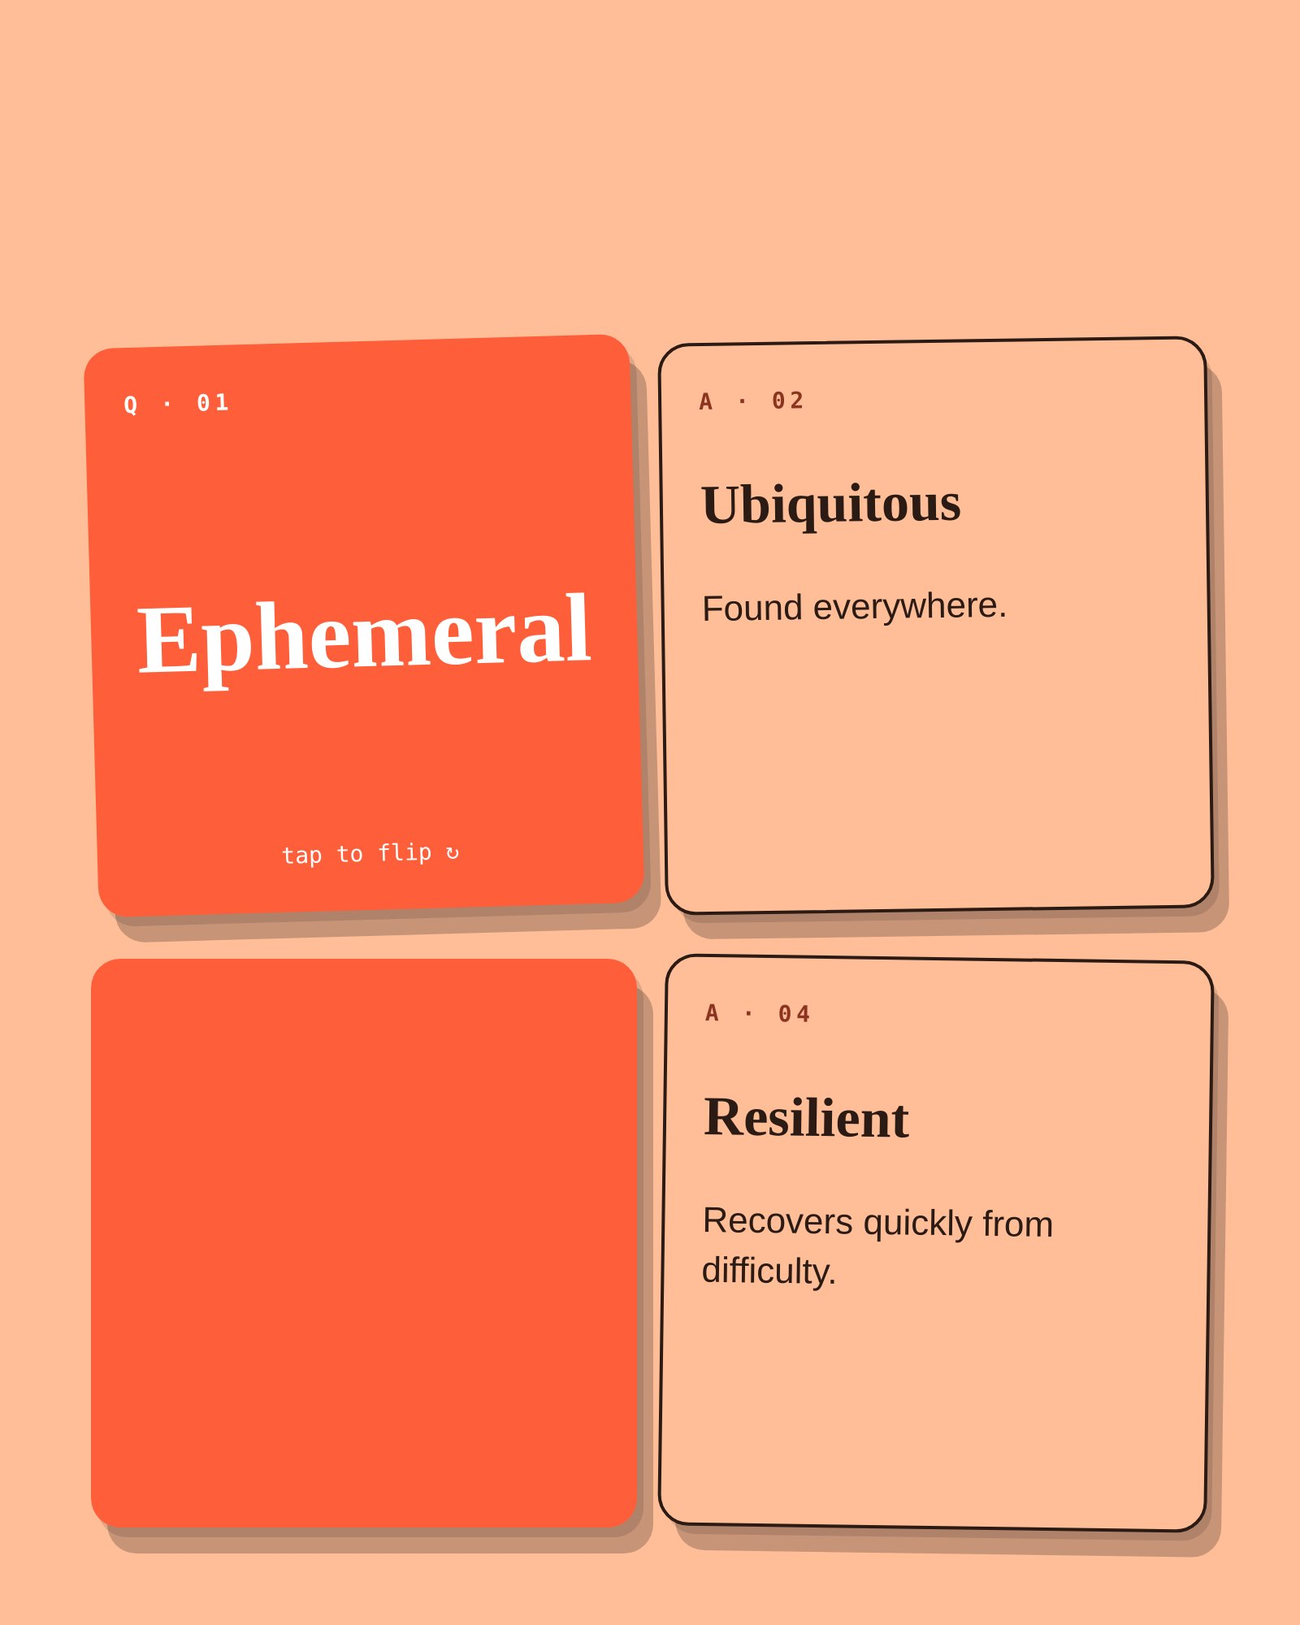
FLASHCARDS
Vocabulary
Q · 03
Candid
tap to flip ↻

