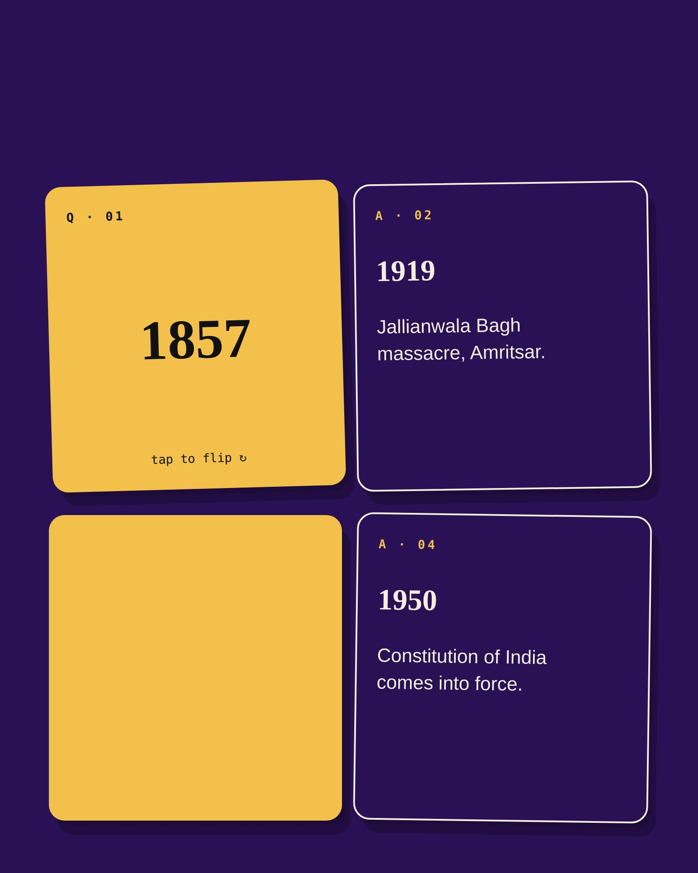
FLASHCARDS
Indian History
Q · 03
1930
tap to flip ↻

