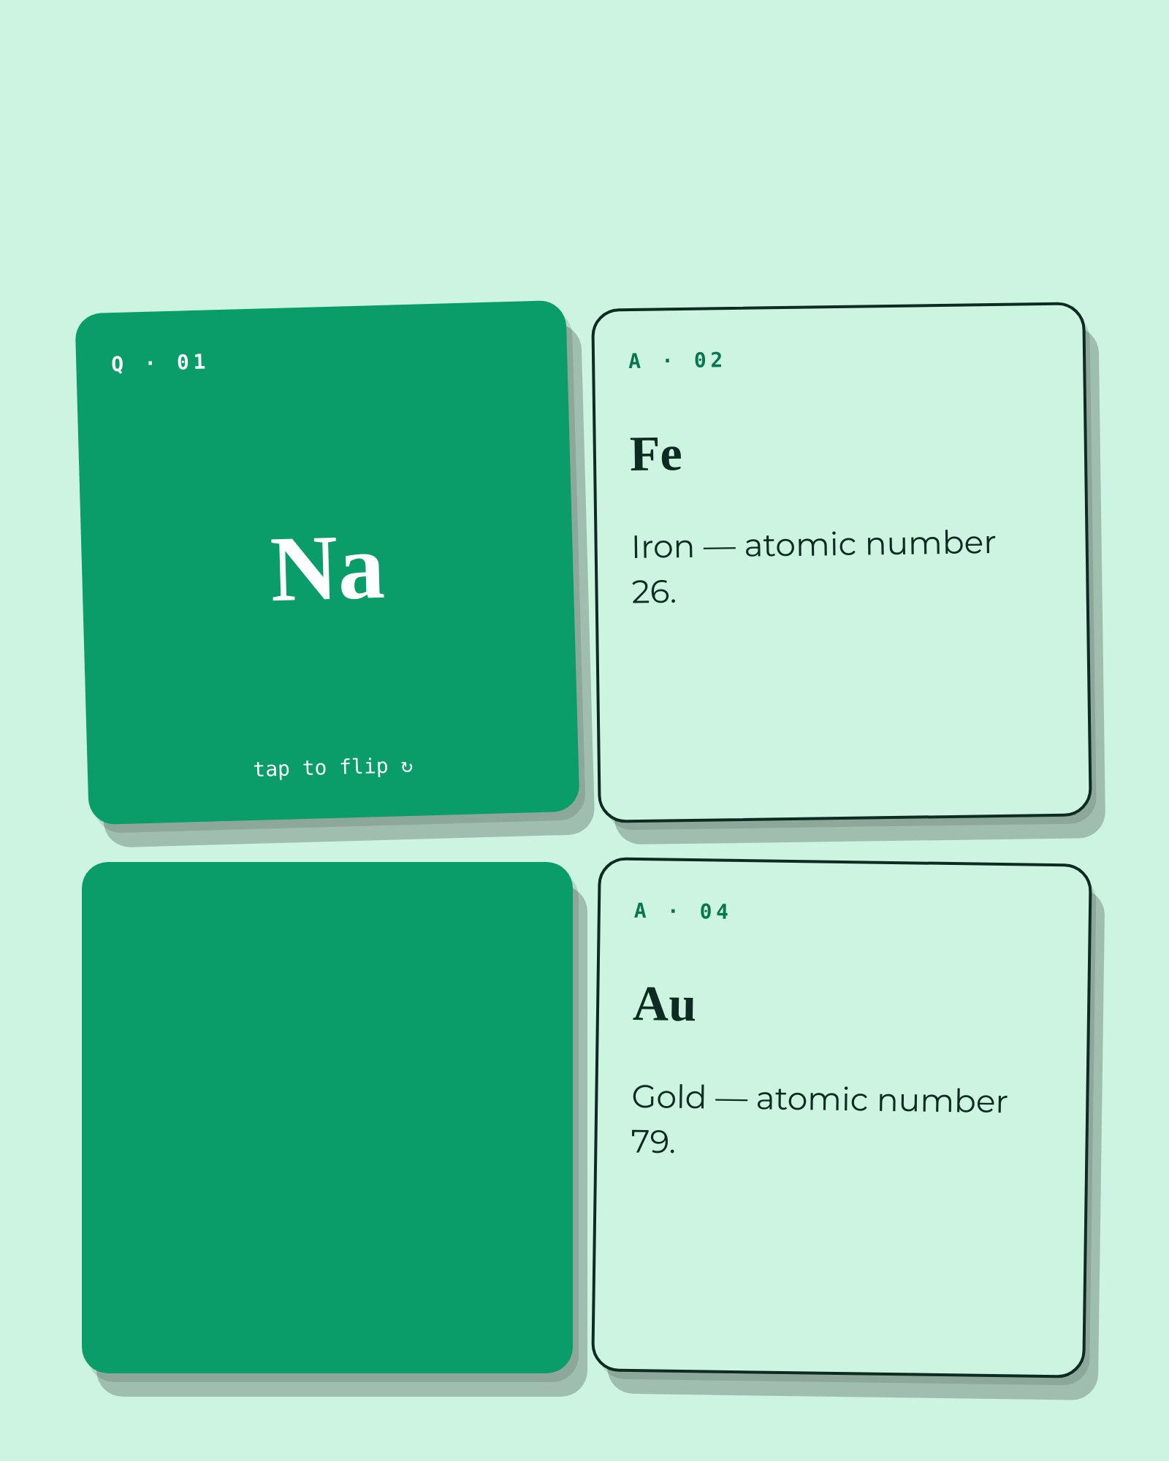
FLASHCARDS
Chemistry Symbols
Q · 03
K
tap to flip ↻

