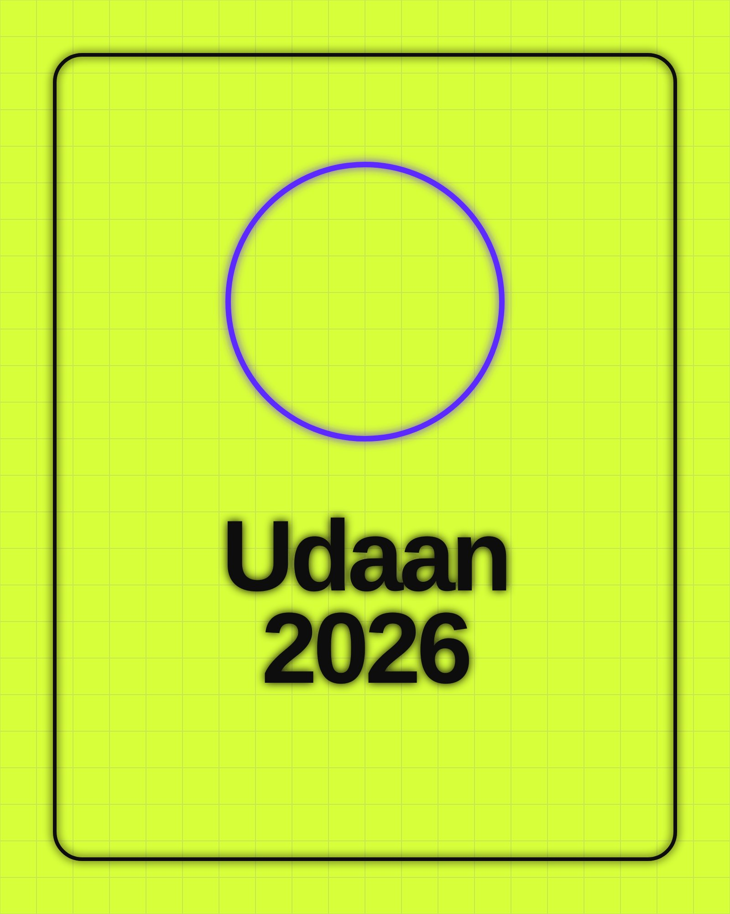
Three days of music, dance, coding contests and
food stalls.
7–9 NOV / COLLEGE ID / 40+

